A Technical Report on the Evaluation of Smart Home Technology

ABSTRACT:

With the development of the Internet of Things, smart home technology has gained popularity in recent years. While it brings convenience to people, some problems with information privacy and energy consumption have also emerged. The report aims to evaluate smart home technology in terms of two selected criteria: privacy and energy consumption, where numerous researchers have been working hard to achieve a balance. Regarding the operating principle, the smart home's composition and specific operation principles are shown in a diagram, assisted with the relevant explanation. Finally, evaluations and recommendations based on two criteria are presented. It is found that smart home technology meets people's needs in terms of privacy and energy consumption, but there is still a lot of room for improvement.

CONTENTS

1. Introduction 2

2. Operating Principles 2
2.1. General principle 2
2.2. Specific principle 2

3. Evaluation 3
3.1 Privacy 3
3.2 Energy consumption 3
3.3 Recommendations 3

4. Conclusion 4

References 4

- Introduction

Artificial intelligence (AI), a new technological science with the ability to reason, discover, generalize and develop theories or methods, shows its great potential in today’s society, with the continuous advancement of computer technology [1]. The applications of AI are as diverse as autonomous driving, medical diagnosing, and option pricing, among which smart home technology is a significant one. Smart home, also known as home automation system, refers to a management system of schedule affairs that controls essential home functions such as lighting, video and sound, heating and cooling, improving home safety, efficiency and convenience [2].

The prototype of the smart home was first proposed in 1966, when a Westinghouse Corporation computer engineer designed a system called Echo IV, which can compute shopping list, control the room’s temperature and turn the appliance on and off [3]. In 1984, the American Association of House Builders (AAHB) put the first smart home into use [2]. In recent years, Internet of Things (IoT) and Cloud Computing technology have extensively promoted smart homes development. More specifically, a wide range of internet-connected devices such as televisions, refrigerators, audio systems can be controlled by home automation system via the cloud computing technology [4].

As the ever-expending types of sensors are used in smart home to monitor people’s lives, J. B. Frank began to be concerned about the potential privacy violations, appealing people to work closely with their legal counsel to develop privacy rights policies [5]. However, G. Bronshteyn [6] held that smart home violates a form of privacy: information privacy, which seemed to be ignored by most people. Moreover, Yang et al. [7] proposed a cost-effective smart meter framework to solve the structural problem to protect privacy. On the other hand, researchers focused on the energy cost of the smart home. Wu et al. [8] found a way of minimizing the sum of energy cost while satisfying adequate privacy protection. In 2019, Chang at al. [9] also figured out a reasonable approach to minimize energy cost and maximizing privacy protection.

Based on the previous studies, privacy safety and energy consumption are two evaluation criteria of the smart home technology. This report will first propose the operating principles of smart home and then evaluate it in terms of privacy and energy cost; some recommendations will be given at the end of the report.

2. Operating Principles

2.1. General principle
Smart home is a communication, hardware, and electronic interface network that operates to integrate daily devices through the Internet. Each device is equipped with a sensor and connected via WiFi; therefore, users can manage it on their smartphones or tablets, whether at home or away.

2.2. Specific principle
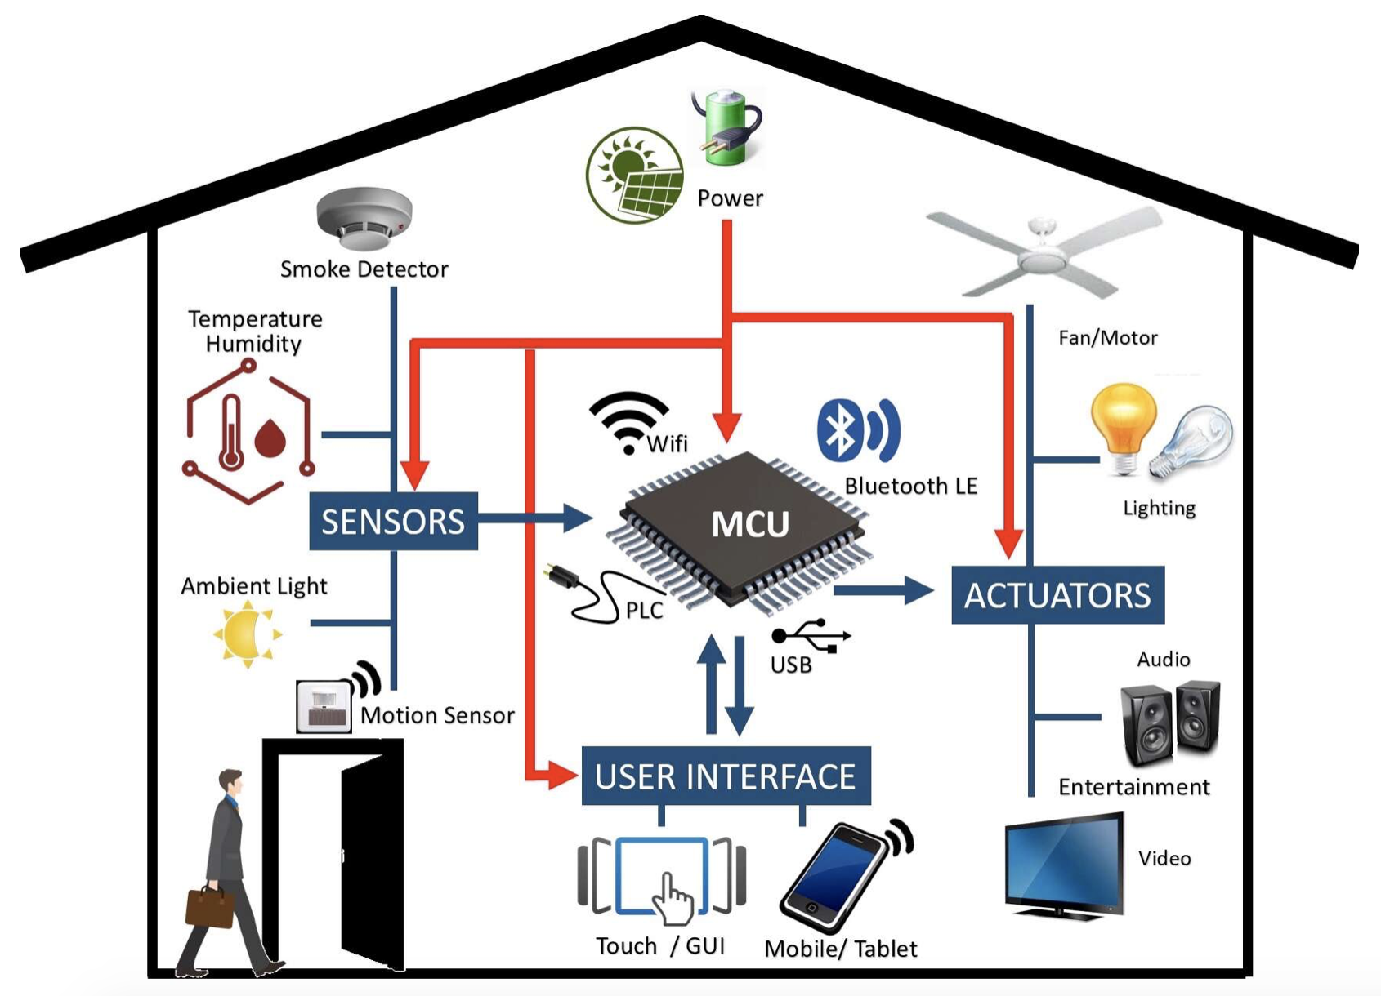
Figure 1. The principle of smart home [10]

As figure 1 shows, there are three main parts of smart home: sensors, controllers, and actuators. Sensors monitor changes in temperature, daylight, humidity, even footstep-induced vibration [11]. Based on the information transmitted by sensors, the Central Processing Unit (CPU) with the Microcontroller Unit (MCU) achieve real-time calculation and processing to control the actuators [11]. Controllers, which refer to devices such as smartphones and personal computers are used to set an automatic operation mode for smart home or control actuators in a real-time. Finally, the progress ends with actuators, namely, loTs of a home automation system, which are programmed to be activated by the CPU or a remote command from a controller.

3. Evaluation

3.1 Privacy
Privacy is a crucial criterion for evaluating smart home technology. In the era of digitalization," privacy" usually refers to information privacy in a particular area [6]. In the field of smart home technology, privacy can be regarded as the information privacy of the usage of electricity. Due to smart meters, almost every use of smart home users is recorded and uploaded to third-party platforms such as Google Home, giving rise to concerns about data privacy [7]. So far, many methods have been proposed to protect the privacy of smart meter information [8] [9] [12]. One of the most common approaches is to use various resources to change standard power consumption patterns, making it difficult for others to infer user activity in the home. For instance, the smart meter can show a reading which indicates a water heater is occupied at any time by using the multiobjective approach [9]. Moreover, Li at al. [12] proposed a framework called PACES, which can generate fake power consumption data and increase the uncertainty of home appliances, thus ensuring the privacy of electricity data. However, some smart home platforms collect people's information at home and learn behaviour patterns, violating user’s privacy, such as a popular smart home platform called IFTTT [13]. In general, although smart home technology can basically meet the standards in terms of privacy, there is still a lot of room for improvement.

3.2 Energy consumption
Energy consumption is another essential criterion for evaluating smart home technology. In other words, energy consumption should be reduced as much as possible. In general, smart devices (IoTs) consume more energy than traditional ones. When a home is equipped with dozens of continuously working wireless sensors, a large quantity of energy is consumed. Grey at al. [14] used a bottom-up approach to develop a new system energy consumption model and quantified the energy consumption of a smart home, and found that smart home consumed more than a third of the energy used by midsized homes. Due to the high rate of smart home technology growth, people's demand for energy conservation is also growing [15]. According to the multiobjective approach proposed by Chang at al. [9], which result in a low peak-to-average ratio (PAR), energy consumption can be reduced by their hybrid multiobjective algorithm on smart grids. Moreover, a Bat algorithm was proposed by Shan at al. [15] in 2020, achieving energy consumption optimization by prediction technology. To be more specific, the peak energy consumption around 29Wh was reduced to 18Wh by this approach [15]. Therefore, by using the above approaches, energy can be saved to some extent. Smart homes, on the other hand, are more energy-efficient than traditional energy consumption. When the house is empty, the motion sensor can detect no user and automatically turn off the lights and TV that the user forgot to turn off, reducing energy consumption [14]. All in all, while smart home technology is sometimes energy-consuming, it meets the requirement of energy conservation based on the approaches proposed.

3.3 Recommendations
Based on the above evaluation, it is believed that smart home technology still has considerable rooms to improve in terms of privacy and energy consumption. First of all, third-party platforms responsible for storing information and controlling appliances need to enhance their security to protect users' data information from stealing. Secondly, the smart meter's operation logic can be improved according to the scheme proposed by many researchers to ensure users' privacy and security. Finally, energy consumption optimisation algorithm should be studied continuously to reduce more energy consumption and make smart home convenient and power-saving.

4. Conclusion

In summary, this report critically evaluates smart home technology in two ways: privacy security and energy consumption. On the whole, smart home technology meets the requirements of these two aspects since there are some protective measures for user privacy and some optimization strategies in energy consumption. It is recommended that more programs to protect user privacy be developed and that more algorithms to reduce energy consumption be studied. The research also has limitations, such as not considering the privacy of user information recorded directly by the sensor. Therefore, it is recommended that the privacy issues posed by smart home technology be fully considered in future studies.

References

[1] S. O. Kuznetsov and A. I. Panov, Artificial Intelligence. [electronic resource] : 17th Russian Conference, RCAI 2019, Ulyanovsk, Russia, October 21–25, 2019, Proceedings, 1st ed. 2019. ed. (Communications in Computer and Information Science: 1093). Springer International Publishing, 2019.

[2] J. M. F. A. Greene, "Home automation (smart homes)," ed: Salem Press, 2020. Available: http://eds.a.ebscohost.com/eds/detail/detail?vid=1&sid=3578e73e-35a8-4fe2-9807-4688c67c5716%40sessionmgr4008&bdata=JnNpdGU9ZWRzLWxpdmUmc2NvcGU9c2l0ZQ%3d%3d#AN=121772851&db=ers

[3]: Electronic Computer for Home Operation (ECHO): The First Home Computer, IEEE Annals of the History of Computing, Vol. 16, No. 3, 1994 pages 59 – 61.

[4]: Q. Zhang, M. Li and Y. Wu, ”Smart home for elderly care: development and challenges in China,” BMC Geriatrics, vol. 20, no. 1, p. 318, Sep. 3, 2020. Available: https://bmcgeriatr.biomedcentral.com/articles/10.1186/s12877-020-01737-y

[5] J. B. Frank, "Dimensions of Privacy and Aging in Place With Smart Home Technology: Legal Considerations for the Seniors Housing Industry," Seniors Housing & Care Journal, Article vol. 26, no. 1, pp. 120-129, 2018. [Online]. Available: http://ez.xjtlu.edu.cn/login?url=http://search.ebscohost.com/login.aspx?direct=true&db=bsu&AN=138646722&site=eds-live&scope=site.

[6] G. Bronshteyn, "Searching the Smart Home," Stanford Law Review, no. 2, p. 455, 2020. [Online]. Available: http://ez.xjtlu.edu.cn/login?url=http://search.ebscohost.com/login.aspx?direct=true&db=edsgea&AN=edsgcl.621405864&site=eds-live&scope=site.

[7]: L. Yang, X. Chen, J. Zhang, and H. V. Poor, "Cost-Effective and Privacy-Preserving Energy Management for Smart Meters," IEEE Transactions on Smart Grid, vol. 6, no. 1, pp. 486-495, 2015, doi: 10.1109/tsg.2014.2343611.

[8]: J. Wu, J. Xiong, and Y. Shi, "Efficient Location Identification of Multiple Line Outages With Limited PMUs in Smart Grids," IEEE Transactions on Power Systems, vol. 30, no. 4, pp. 1659-1668, 2015, doi: 10.1109/tpwrs.2014.2357751.

[9] H.-H. Chang, W.-Y. Chiu, H. Sun, and C.-M. Chen, "User-Centric Multiobjective Approach to Privacy Preservation and Energy Cost Minimization in Smart Home," IEEE Systems Journal, vol. 13, no. 1, pp. 1030-1041, 2019, doi: 10.1109/jsyst.2018.2876345.

[10]: Embedded Stuff, "Designing power-efficient and secure home automation systems" embedded.com. https://www.embedded.com/designing-power-efficient-and-secure-home-automation-systems/ (accessed Nov. 12, 2020)

[11]: F. Li, J. Clemente, M. Valero, Z. Tse, S. Li and W. Song, "Smart Home Monitoring System via Footstep-Induced Vibrations," in IEEE Systems Journal, vol. 14, no. 3, pp. 3383-3389, Sept. 2020, doi: 10.1109/JSYST.2019.2937960.

[12] B. Li, J. Wu, and Y. Shi, "Privacy-Aware Cost-Effective Scheduling Considering Non-Schedulable Appliances in Smart Home," presented at the 15th IEEE International Conference on Embedded Software and Systems, 2019, Accessed: March 17, 2021 [Online]. Available: http://arxiv.org/abs/1909.05300

[13] R. Xu, Q. Zeng, L. Zhu, H. Chi, X. Du, and M. Guizani, "Privacy Leakage in Smart Homes and Its Mitigation: IFTTT as a Case Study," IEEE Access, vol. 7, pp. 63457-63471, 2019, doi: 10.1109/access.2019.2911202.

[14] C. Gray, R. Ayre, K. Hinton, and L. Campbell, "‘Smart’ Is Not Free: Energy Consumption of Consumer Home Automation Systems," IEEE Transactions on Consumer Electronics, vol. 66, no. 1, pp. 87-95, 2020, doi: 10.1109/tce.2019.2962605.

[15] A. S. Shah, H. Nasir, M. Fayaz, A. Lajis, I. Ullah, and A. Shah, "Dynamic User Preference Parameters Selection and Energy Consumption Optimization for Smart Homes Using Deep Extreme Learning Machine and Bat Algorithm," IEEE Access, vol. 8, pp. 204744-204762, 2020, doi: 10.1109/access.2020.3037081.

